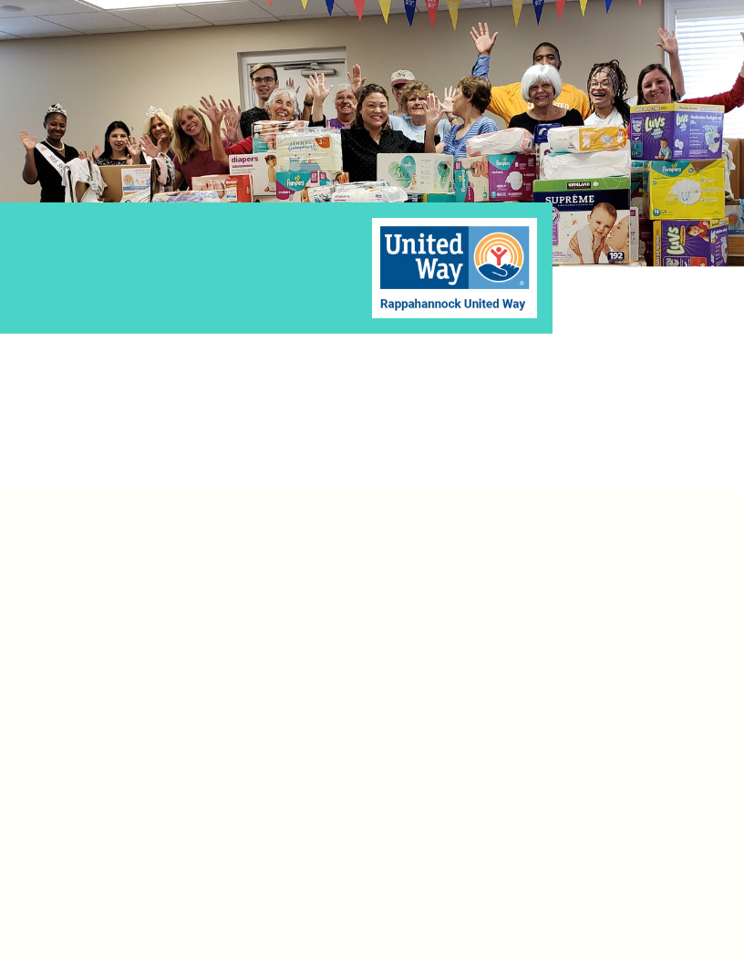

Sample Messaging

[SAMPLE EMAIL]
I am excited to announce that [group/company] will be participating in Rappahannock United Way’s “Healthy Beginnings” baby shower drive!
Rappahannock United way is collecting new, age-appropriate supplies for new born babies to distribute to local families through local nonprofits. Healthy beginnings for babies and young children are vital for early childhood health and success. Providing supplies like diapers and wipes can help stretch a family’s budget and keep them from falling behind, financially.
We’re collecting new basic clothing items as well as diapers and wipes to delivery to United Way. Please bring your items to [location] no later than [date before September 18th]. I will take the lead on delivering items to United Way.
Please join me in this effort to help local families build strong foundations!
PS: There’s an Amazon Wish list that makes it easy! https://www.amazon.com/hz/wishlist/ls/30628F3BKTO7H?ref_=wl_share

