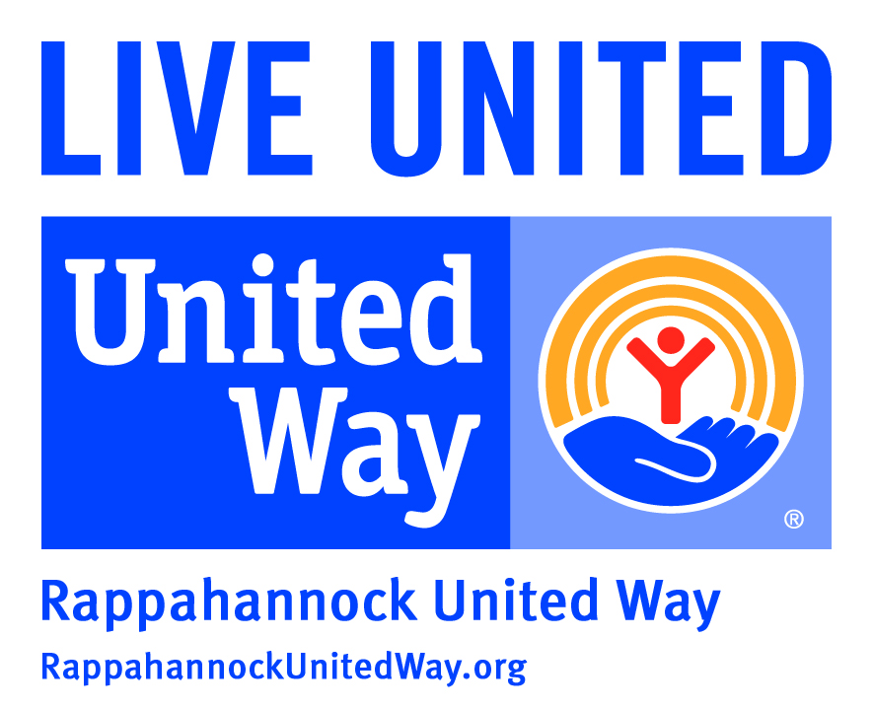
Contact: Janel Donohue
Rappahannock United Way President FOR IMMEDIATE RELEASE
540-373-0041 x.307
jdonohue@rappahannockunitedway.org

RAPPAHANNOCK UNITED WAY WELCOMES NEW STAFF MEMBERS

March 29, 2017 – Fredericksburg, VA – Rappahannock United Way is proud to welcome two new employees to their staff. Ann Jones joins the team as Director of Resource Development. Bobby Hebert joins the team as Corporate Relationship Manager. Ann will be responsible for individual giving, major gifts and legacy giving. Bobby will be responsible for corporate gifts, workplace campaigns and sponsorships.

Ann comes to Rappahannock United Way from the senior industry. She was Director of a Del Webb community for 6 years and most recently Director of Business Development for Comfort Keepers for the past 4 years. After many Air Force moves, Ann and her husband settled in the Fredericksburg area in 2003 and are now proud to call this home. They have been married for 30 years and have 3 children. Two of their children are married and one is in college.
“I love this community,” said Jones. “The people, the history, the active lifestyle, the beauty. I am excited to be part of an organization which makes such a direct impact on our community.”

Bobby comes to Rappahannock United Way after a 30-year career at The Free Lance-Star as a Multi-Media Advertising Specialist. Bobby is a Caroline County native and currently lives with his wife in Spotsylvania. He has been married for 28 years and has two adult children. “I am new to Rappahannock United Way, but am not new to the community, having spent the last 30 years working at The Free Lance-Star newspaper,” said Hebert. “I am so excited to be a part of another organization with deep community roots and a commitment to making a local impact.”

“We are thrilled to have Ann and Bobby on board,” said Janel Donohue, President of Rappahannock United Way. “They both have such a passion for making a difference in our community. They are eager to connect more people to Rappahannock United Way and impact thousands of local individuals this year in the areas of Education, Health and Financial Stability.”

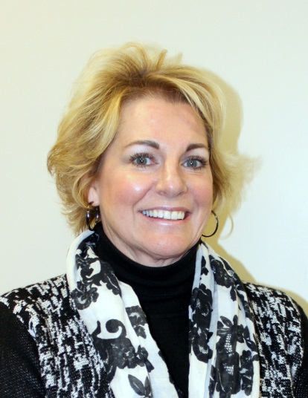
Ann Jones, Director of Resource Development, Rappahannock United Way

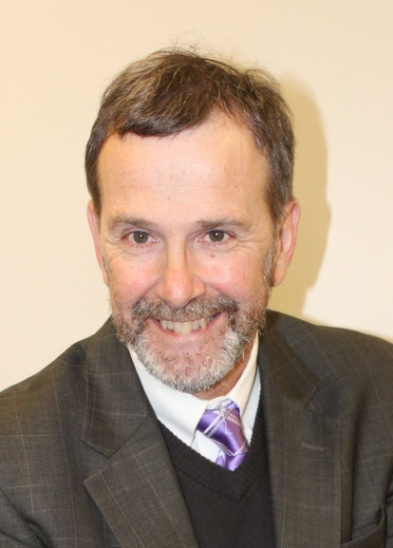
Bobby Hebert, Corporate Relationship Manager, Rappahannock United Way

About Rappahannock United Way
Founded in 1939, Rappahannock United Way is a local nonprofit organization serving Fredericksburg, Caroline, King George, Spotsylvania and Stafford. Our mission is to improve lives by mobilizing the caring power of our community. Our goal is to have more households emerge from poverty and achieve greater financial stability. Together, we can create opportunities for a better tomorrow. That’s what it means to LIVE UNITED.

###

