 |  | Advocate  RUW Advocates for long lasting changes that address the underlying causes of poverty in our area. |  | 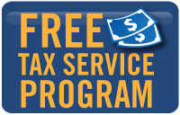
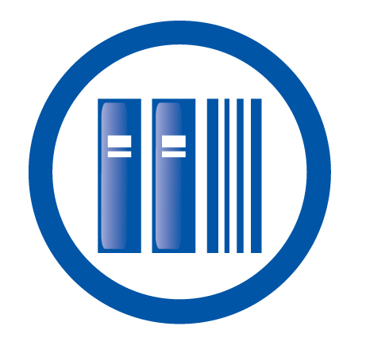 |  | Education  This year, RUW is investing  $247,000 in local Education programs
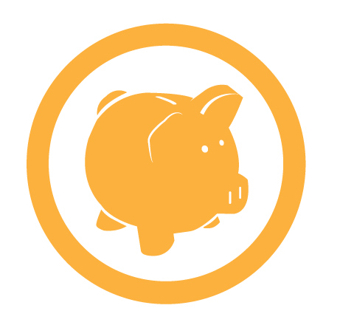 |  | GIVE  A donation to RUW turns $1 into $10! Make an investment in your community by donating today! |  | 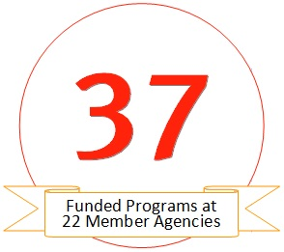
 |  | Health  This year, RUW is investing $435,250 in local Health programs
 |  | Income  This year, RUW is investing $291,000 in local Income programs |  | 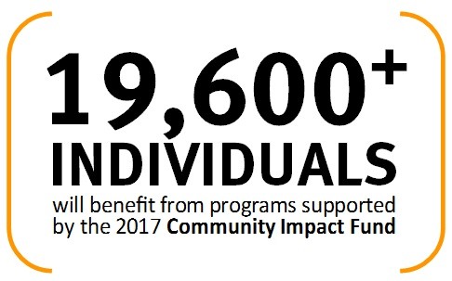
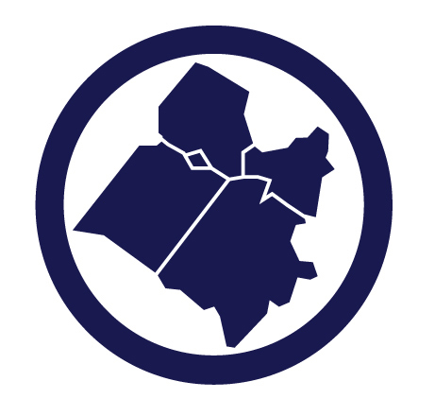 |  | Planning District 16:  Caroline, King George, Fredericksburg, Spotsylvania and Stafford. Local donations support  Local programs!
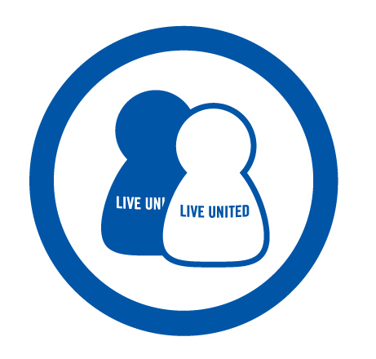 |  | Volunteer  Volunteering is a great investment in your community!  Visit RUWVolunteer.org to learn more! |  | 
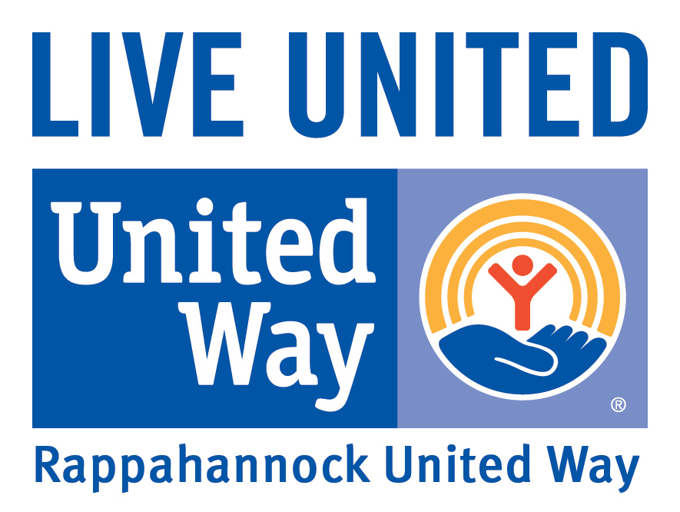 |  |   2-1-1  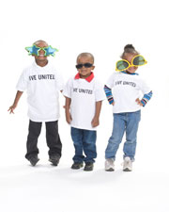  RUW partners with Virginia 2-1-1 to connect people to the programs and services they need. |  | Stay up to date at  https://www.facebook.com/  rappahannockunitedway/

RUW is a Guidestar GOLD rated nonprofit
 |  |  |  | RUW is a Guidestar GOLD rated nonprofit

